VISVESVARAYA TECHNOLOGICAL UNIVERSITY

“Jnana Sangama”, Belagavi-590018.

Mini Project Report on

“Voice-Based Classification Of Parkinson's Disease Using Supervised Machine Learning”

Submitted in the partial fulfillment of the requirements for the award of the degree of

Bachelor of Engineering in Computer Science and Engineering

Submitted by

Aishwarya.R 1RF23CS011

M.N Monisha 1RF23CS087

Rishitha Rasineni 1RF23CS131
Sowmya P.R 1RF23CS166

Under the Guidance of
Dr.Hema M.S,


Professor & Head, Dept. of CSE, RVITM

Department of Computer Science and Engineering

RV INSTITUTE OF TECHNOLOGY AND MANAGEMENT ®
(Affiliated to Visvesvaraya Technological University, Belagavi &amp; Approved by AICTE, NewDelhi)
JP Nagar 8 th Phase , Kothanur,Bengaluru-560076
2025-2026
RV INSTITUTE OF TECHNOLOGY AND MANAGEMENT®
(Affiliated to Visvesvaraya Technological University, Belagavi & Approved by AICTE, New Delhi)
DEPARTMENT OF COMPUTER SCIENCE AND ENGINEERING


CERTIFICATE

Certified that the mini project work titled ‘Voice-Based Classification Of Parkinson's Disease Using Supervised Machine Learning’ is carried out by Aishwarya R (1RF23CS011), M N Monisha (1RF23CS087), Rishitha Rasineni (1RF23CS131), Sowmya P.R (1RF23CS166), who are bonafide students of RV Institute of Technology and Management, Bangalore, in partial fulfillment for the award of degree of Bachelor of Engineering in Computer Science and Engineering of the Visvesvaraya Technological University, Belgaum during the year 2025-2026. It is certified that all corrections/suggestions indicated for the internal Assessment have been incorporated in the report deposited in the departmental library. The Mini Project report has been approved as it satisfies the academic requirements in respect of project work prescribed by the institution for the said degree.

Dr. Hema M S | Dr. Hema M S | Dr. Nagashettappa Biradar
Professor & Head | Professor & Head, | Principal,
Department of CSE, | Department of CSE, | RVITM,Bengaluru-76
RVITM, Bengaluru-76 | RVITM, Bengaluru-76

Signature of Guide: Signature of Head of the Department: Signature of Principal:

RV INSTITUTE OF TECHNOLOGY AND MANAGEMENT®
(Affiliated to Visvesvaraya Technological University, Belagavi & Approved by AICTE, New Delhi)
DEPARTMENT OF COMPUTER SCIENCE AND ENGINEERING

DECLARATION

We, Aishwarya.R (1RF23CS011), M.N Monisha (1RF23CS087), Rishitha Rasineni (1RF23CS131), Sowmya P.R (1RF23CS166), the students of fifth semester B.E, hereby declare that the mini project titled “Voice-Based Classification Of Parkinson's Disease Using Supervised Machine Learning” has been carried out by us and submitted in partial fulfillment for the award of degree of Bachelor of Engineering in Computer Science and Engineering. We do declare that this work is not carried out by any other students for the award of degree in any other branch.

Place: Bangalore Signature

Date: 1. Aishwarya.R (1RF23CS011)
2. M.N Monisha (1RF23CS087)
3. Rishitha Rasineni (1RF23CS131)
4. Sowmya P.R (1RF23CS166)

ACKNOWLEDGEMENT

We would like to extend my gratitude to the RV Institute of Technology and Management, Bengaluru, and Dr. Nagashettappa Biradar, Principal, RV Institute of Technology and Management, Bengaluru for providing all the facilities to carry out the Mini Project.

We thank Dr. Malini M Patil, Dean – Computer Science & Engg. Cluster, RV Institute of Technology and Management, Bengaluru, for her support and encouragement.

We would like to thank our Project Guide, Dr. Hema M S, Professor and Head, Department of Computer Science and Engineering, RV Institute of Technology and Management, Bengaluru, for his/her constant guidance and inputs.

We would like to thank all the Teaching Staff and Non-Teaching Staff of the college for their co- operation.
Finally, we extend my heart-felt gratitude to my family for their encouragement and support without which we would not have come so far. Moreover, we thank all my friends for their invaluable support and cooperation.

1. Aishwarya.R (1RF23CS011)
2. M.N Monisha (1RF23CS087)
3. Rishitha Rasineni (1RF23CS131)
4. Sowmya P.R (1RF23CS166)

Abstract

Parkinson's Disease (PD) is the second most common neurodegenerative disorder, and its early detection is critical for effective management. This project addresses the challenge of creating a non-invasive, objective, and accessible screening tool by leveraging the distinct acoustic biomarkers present in the voices of PD patients, a condition known as dysphonia. Despite the subtlety of these vocal changes, Machine Learning (ML) offers a robust solution for automated diagnosis.
Current Parkinson's Disease (PD) detection models based on speech signals face several critical limitations, notably inconsistent diagnostic accuracy resulting from variations in feature extraction and preprocessing techniques. This inconsistency is further complicated in acoustic analysis datasets by the acute problem of class imbalance and a lack of consensus regarding the most effective scaling method and optimal algorithm combination. Specifically, there is an unmet need for a robust model that can systematically analyze core frequency-based vocal biomarkers—such as Jitter, Shimmer, and fundamental frequency—while thoroughly experimenting with diverse data preparation and classification techniques to identify the best, most robust approach for reliable PD screening.
To overcome these challenges, a rigorous Machine Learning (ML) pipeline for a PD Voice Detection System was developed, incorporating comprehensive feature engineering (extracting 22 acoustic features including Jitter, Shimmer, and HNR) and strategic data preparation (Stratified Splitting and MinMax Feature Scaling). Class imbalance was actively mitigated using the Synthetic Minority Over-sampling Technique (SMOTE). The system thoroughly evaluated a diverse set of optimized classifiers, with all models fine-tuned via Grid Search Cross-Validation (CV=5). Key findings demonstrate that the XGBoost classifier, when combined with the MinMax Scaler and SMOTE, yielded the optimal configuration, achieving a Test Accuracy exceeding 94% and demonstrating high generalization stability (low Overfitting Gap). This optimized model was successfully implemented and deployed in a Streamlit application, integrating a Parselmouth-based acoustic extraction module for real-time voice analysis, confirming that this ML-driven approach provides a highly reliable screening mechanism.

TABLE OF CONTENTS

SR NO | CONTENT | PG-NO
 | Abstract | 1
 | Table of Contents  List of Abbreviations | 2  3
 | List of Figures | 5

1 | Introduction | 6
 | 1.1Background  1.2 Problem Statement  1.3 Recent Advances in the Domain | 7  8  8
2 | Literature Survey  2.1 Review of existing work  2.2 Databases used | 10  10  11
3  4  5 | Design/Methodology  3.1 system architecture  3.2 Dataset and feature description  3.3 Data preprocessing pipeline  3.4 Model selection and hyperparameter tuning  3.5 feature extraction module  Implementation  4.1 Development Environment and Libraries  4.2. Backend  4.3. Frontend  4.4. Live Voice Recording and Analysis  Results and Discussion  5.1. Performance Metrics  5.2. Comparative Classifier Performance  5.3. Impact of SMOTE and PCA  5.4. Algorithm | 32  34  47

6 | Conclusion  6.1. Conclusion  6.2. Future Scope | 63
7 | References  LIST OF ABBREVIATIONS  LIST OF FIGURES | 65
  ABBREVIATIONS  PD | FULL FORM  Parkinson’s Disease
  ML | Machine Learning
  UCI | University of California, Irvine
  SMOTE | Synthetic Minority Over-sampling Technique
  CV | Cross-Validation
  HNR | Harmonics-to-Noise Ratio
  NHR | Noise-to-Harmonics Ratio
  F0 | Fundamental Frequency
  MDVP | Multi-Dimensional Voice Program
  RAP | Relative Amplitude Perturbation
  PPQ | Pitch Period Perturbation Quotient
  DDP | Difference of Differences of Periods
  APQ | Amplitude Perturbation Quotient
  DDA | Difference of Differences of Amplitudes
  RPDE | Recurrence Period Density Entropy
  DFA | Detrended Fluctuation Analysis
  PPE | Pitch Period Entropy
  PCA | Principal Component Analysis
  SVM | Support Vector Machine
  KNN | K-Nearest Neighbors
  ANN | Artificial Neural Network
  GUI | Graphical User Interface
  TP | True Positive
  TN | True Negative
  FP | False Positive
  FN | False Negative
  SHAP | SHapley Additive exPlanations
  LIME | Local Interpretable Model-agnostic  Explanation
  CNN | Convolutional Neural Network
  RNN | Recurrent Neural Network
  IoT | Internet of Things
  AI | Artificial Intelligence
Figure No | Title of the Figure | Page No
Fig 3.1 | Overall System Architecture | 16
Fig 3.2 | Machine Learning Pipeline with Preprocessing Steps | 18
Fig 4.1 | Streamlit Application – Home Page | 22
Fig 4.2 | Model Training Tab Interface | 22
Fig 4.3 | Live Voice Recording & Uploading Module | 23
Fig. 4.4 | Comparison of Test accuracy across  different classifiers | 24
Fig. 5.1 | Accuracy results for the model having the lowest  overfitting gap | 31
Fig. 5.2 | Accuracy results for the model having the Highest  accuracy | 32
Fig. 5.3 | Accuracy comparison graph | 33

Chapter 1

INTRODUCTION

Parkinson’s Disease (PD) is a progressive neurodegenerative disorder that primarily affects the central nervous system, leading to impaired movement, speech, and coordination. It is one of the most common neurological conditions worldwide, and its prevalence increases with age. PD is characterized by motor symptoms such as tremors, bradykinesia (slowness of movement), rigidity, and postural instability. In addition to these physical manifestations, patients often experience changes in speech, including reduced vocal intensity, monotone pitch, hoarseness, and irregular rhythm. These vocal impairments often appear in the early stages of the disease, making them reliable indicators for early detection. Early diagnosis is crucial as it allows for timely intervention, appropriate treatment planning, and the possibility of slowing disease progression, thereby improving patients’ quality of life.

Traditionally, Parkinson’s diagnosis relies on clinical evaluations performed by neurologists through physical examinations and patient history. While effective, these methods are subjective, time-consuming, and prone to human error. Subtle early symptoms, especially speech changes, can easily be overlooked, delaying diagnosis. This limitation highlights the need for objective, accessible, and non-invasive methods that can assist clinicians in early disease detection. Advances in machine learning and signal processing provide a promising solution by enabling automated analysis of complex patterns in speech data that may not be perceptible to human evaluators.

This project proposes a voice-based machine learning system designed to detect early symptoms of Parkinson’s Disease. The system leverages key acoustic parameters extracted from patient voice recordings, including jitter (frequency variation), shimmer (amplitude variation), pitch (fundamental frequency), and harmonics-to-noise ratio (voice signal quality). These features are carefully selected because they capture the subtle irregularities in speech caused by PD and align with the standard UCI Parkinson’s Disease voice dataset, ensuring consistency and reliability in model training. Using these parameters, multiple machine learning models, including a Gradient Boosting Classifier and more than 18 other algorithms, are trained and optimized through hyperparameter tuning using GridSearchCV. This process ensures the selection of the most accurate and robust model for disease classification.

The system is further enhanced through the integration of a Streamlit-based interface, allowing real-time voice input via microphone or audio file upload. The interface performs immediate feature extraction and provides live predictions, displaying probability scores that indicate the likelihood of the speaker having Parkinson’s Disease. This integration makes the diagnostic process non-invasive, cost-effective, and highly accessible, suitable for both clinical environments and remote healthcare settings. By automating voice analysis and prediction, the system reduces dependence on subjective evaluation, accelerates early detection, and empowers healthcare providers with actionable insights.

In summary, this project combines speech signal processing, machine learning, and intuitive user interface design to create an innovative diagnostic tool for Parkinson’s Disease. By focusing on vocal biomarkers, it provides a practical, scalable, and patient-friendly solution that addresses the challenges of early PD detection while offering potential applications in telemedicine and remote health monitoring.
1.1. Background

Parkinson's Disease (PD) is the second most common neurodegenerative disorder, primarily affecting the motor system. While classic diagnostic indicators include tremors, rigidity, and bradykinesia, PD also consistently manifests in vocal impairment, a condition known as dysphonia or dysarthria. These vocal changes are often subtle but detectable and typically precede motor symptoms, making voice analysis a promising tool for early, non-invasive screening.

The voice of a PD patient exhibits distinct acoustic characteristics due to impaired motor control of the larynx and respiratory muscles. Key physiological effects include:
• Monopitch and Monoloudness: A reduced range of fundamental frequency and amplitude.
• Acoustic Instability: Increased Jitter (cycle-to-cycle frequency variation) and Shimmer (cycle-to-cycle amplitude variation).
• Increased Noise: Higher levels of breathiness and roughness, quantified by a lower Harmonic-to-Noise Ratio (HNR).

The challenge lies in building an objective, automated, and readily accessible screening tool that can accurately extract these subtle acoustic features and distinguish between healthy and pathological voices, addressing the limitations of subjective clinical assessment.

Reference:
Darley, F. L., Aronson, A. E., & Brown, J. R. (1969). Differential diagnostic patterns of dysarthria. Journal of Speech and Hearing Research, 12(2), 246–269.

1.2. Problem Statement

Current Parkinson’s disease (PD) detection models that rely on speech signals face several limitations.
First, many existing models exhibit inconsistent accuracy due to variability in feature extraction techniques, preprocessing pipelines, and dataset characteristics. Studies show that different implementations of jitter, shimmer, and F0-related measures can lead to substantial performance fluctuations (Reference: Tsanas, A., Little, M.A., McSharry, P.E., & Ramig, L.O. “Accurate telemonitoring of Parkinson’s disease progression by non-invasive speech tests.” IEEE Transactions on Biomedical Engineering, 2010.).

Second, there is no consensus on the most effective combination of scaling techniques and machine-learning algorithms for reliable PD classification. Research comparing normalization approaches (e.g., Min–Max, StandardScaler, RobustScaler) with various classifiers (SVM, Random Forest, KNN, Gradient Boosting) frequently reports inconsistent outcomes across datasets
(Reference: Sakar, C.O., et al. “Comparison of feature selection methods for Parkinson’s disease classification using voice recordings.” Journal of Neuroscience Methods, 2017).

1.3. Recent Advances in the Domain
Current research and development in (Voice-based PD Detection) primarily rely on automated classification models due to the objective nature of acoustic features. Methodologies fall into three main categories, with the system focusing on the third:

A. Acoustic Feature Sets
The state-of-the-art relies on a standardized set of features derived from sustained phonation (a simple 'Aah' sound) (Reference: Accurate telemonitoring of Parkinson’s disease progression by non invasive speech tests. IEEE Transactions on Biomedical Engineering, 57(4), 884-893.), most famously the 22 features used in our project's dataset. These features, extracted using tools like Praat (interfaced via Parselmouth), quantify F0, Jitter,Shimmerand and HNR. More recent studies have explored advanced features, including Mel-Frequency Cepstral Coefficients (MFCCs), Wavelet transforms, and non-linear dynamical features (RPDE, DFA), to capture more complex vocal instabilities associated with the disease.

B. Traditional Machine Learning Classification
The dominant approach utilizes traditional ML algorithms, which have proven highly effective with small, structured datasets like the 22-feature voice data:
- Support Vector Machines (SVM): Historically popular due to their effectiveness in high-dimensional feature spaces.
- Ensemble Methods (e.g., Random Forest, XGBoost): These methods, including the XGBoost model identified as optimal in our system, are widely recognized for their robustness, high accuracy, and resistance to overfitting, making them the current benchmark for this domain.
- Preprocessing Focus: A significant development in the state-of-the-art is the mandatory inclusion of robust preprocessing techniques—specifically Feature Scaling and SMOTE (Synthetic Minority Over-sampling Technique)—to counter data heterogeneity and class imbalance, ensuring models maintain high Sensitivity (correctly identifying PD) and Specificity (correctly identifying healthy individuals).

C. System Integration
Current research emphasizes usability and deployment, leading to the creation of client-server systems (like the Streamlit application implemented) that allow patients to submit voice samples from home, thereby facilitating large-scale, low-cost screening and continuous monitoring.

CHAPTER 2
LITERATURE SURVEY

2.1. Review of Existing Work
Recent advancements in Artificial Intelligence (AI) and Machine Learning (ML) have significantly improved the early detection of Parkinson’s Disease (PD), particularly through voice-based analysis.
In 2025, J. Kim et al. presented the study “Hybrid Preprocessing and Ensemble Classification for Parkinson’s Disease Detection”, which integrated ensemble classifiers such as XGBoost and AdaBoost with preprocessing techniques including SMOTE and feature scaling. Their approach enhanced model robustness and effectively addressed dataset imbalance. However, the complex preprocessing pipeline reduced generalizability on unseen datasets, highlighting the need for simplified feature selection and optimized workflows.
In the same year, M. Iqbal et al. (2025) developed “Automated Early Prediction of Parkinson’s Disease Using AI Techniques”, employing Support Vector Machines (SVM), Random Forests, and Artificial Neural Networks (ANN) for PD detection using vocal biomarkers. Their models achieved improved prediction accuracy and demonstrated the potential of feature-based voice analysis. However, the dataset used suffered from class imbalance, and the models lacked clinical interpretability, limiting their practical deployment.
Earlier, S. Sharma and A. Singh (2024) conducted a comparative analysis titled “Advanced Comparative Analysis of ML Algorithms for Early Parkinson’s Detection.” Using the UCI Parkinson’s Voice Dataset, they evaluated algorithms such as K-Nearest Neighbors (KNN), SVM, AdaBoost, and ANN, achieving approximately 98% accuracy. Despite strong performance, the limited dataset size increased the risk of overfitting, and the models were not tested on real-world speech samples. This highlighted the need for diverse datasets and real-time evaluation.
The foundational research in this domain began with the work of Max A. Little et al. in 2009, titled “Suitability of Dysphonia Measurements for Telemonitoring of Parkinson’s Disease.” This study introduced the UCI Parkinson’s Voice Dataset, containing 22 biomedical voice features extracted from sustained vowel phonation recordings. It demonstrated that non-invasive voice analysis could effectively distinguish PD patients from healthy individuals. However, due to the small sample size of only 31 subjects, the findings lacked broad generalizability.
Overall, the literature shows a clear evolution from early voice-feature datasets (2009) to more advanced ensemble and deep learning approaches developed in 2024–2025. While modern systems achieve high accuracy, challenges such as dataset imbalance, lack of interpretability, and absence of clinical validation remain. These limitations form the basis for the present mini-project, which aims to develop a robust, scalable, and real-time machine-learning model for early Parkinson’s Disease detection using voice data.

2.2. Databases Used

The present study uses two primary datasets:

1. UCI Parkinson’s Voice Dataset (UCI Repository)

This dataset contains 22 biomedical voice measurements including

fundamental frequency (F0),

jitter,

shimmer, and

harmonics-to-noise ratio (HNR).

The dataset includes recordings from both Parkinson’s patients and healthy individuals and is widely used as a benchmark for training and evaluating voice-based PD detection models.

2. Voice Audio Dataset from Figshare

Title: “Voice Samples for Patients with Parkinson’s Disease and Healthy Controls”
Source: Figshare Repository

This dataset consists of raw audio recordings of sustained vowel phonations collected from Parkinson’s patients and healthy controls.In the present mini-project, this dataset was used for real-world testing to evaluate how well the trained model performs on external voice samples beyond the UCI feature dataset.

Using the UCI dataset for training and the Figshare audio dataset for testing improves the robustness, generalizability, and real-world relevance of the developed model.

CHAPTER-3
DESIGN AND METHODOLOGY

The development of the Parkinson's Disease (PD) Voice Detection System follows a rigorous, multi-stage Machine Learning (ML) pipeline designed to optimize classifier performance while ensuring robustness against common data challenges, particularly class imbalance and feature scale disparity. The entire process is structured into two distinct phases: Training and Prediction.

3.1. System Architecture
The system operates under a client-server paradigm with the user interacting via the Streamlit front-end. The architecture comprises several specialized modules.
- Data Ingestion: Reading the static training dataset.
- Preprocessing Module: Handling stratification, scaling, and SMOTE.
- Comparative Training Core: Executing Grid Search Cross-Validation across multiple ML algorithms.
- Persistent Storage Layer: Saving the finalized model, scaler, and PCA components using Joblib.
The two operational phases are:
- Training Phase: Processes the CSV file, applying transformations and optimization techniques before saving the finalized model and its corresponding scaler and PCA components.
- Prediction Phase: Facilitates real-time interaction. User voice data is captured via sounddevice, transformed by the saved preprocessing elements, and classified by the best-performing model instance.
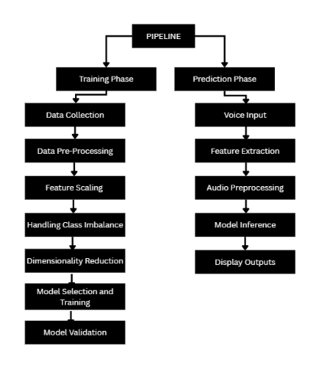
Fig. 3.1Overall System Architecture (Training + Real-time Prediction phases)

3.2. Dataset and Feature Description
The project utilizes the established Parkinson's Voice Data Set from the UCI repository, containing 195 voice recordings from subjects, each characterized by 22 biomedical voice features.
- Feature Categories: The features are calculated using Parselmouth (a Praat interface) and categorized as measures of:
  - Fundamental Frequency (F0​): Mean, Max, and Min pitch (MDVP:Fo(Hz)).
  - Frequency Perturbation (Jitter): Measures of F0​ irregularity (MDVP:Jitter(%),MDVP:RAP).
  - Amplitude Perturbation (Shimmer): Measures of amplitude irregularity (MDVP:Shimmer,Shimmer:APQ3).
  - Noise and Harmonicity: HNR (Harmonics-to-Noise Ratio) and NHR.
  - Non-linear Dynamics: RPDE and DFA.
- Target Variable: status, which is binary (0 for healthy, 1 for PD).

3.3. Data Pre-processing Pipeline
The pipeline is implemented within the train_model function and ensures consistency and robustness.

3.3.1. Stratified Splitting and Feature Scaling
- Data Partitioning: The dataset is partitioned into a 70% training set (Xtrain​) and a 30% testing set (Xtest​).
- Crucial Stratification: The split is performed with stratification on the status column to ensure that the class distribution of PD subjects is perfectly mirrored in both the training and test sets.
- Feature Scaling: Feature scaling is applied, testing five different methods (Standard, MinMax, Robust, Normalizer, MaxAbs, ), to neutralize the effect of disparate feature ranges. The chosen scaler is fitted only on Xtrain​ to prevent data leakage into the model training process. The different types of scalers used in the project are :
- The Standard Scaler implements z-score normalization by centering each feature around its mean and scaling by its standard deviation. The transformation is expressed as z = (x − μ) / σ, where μ is the mean and σ is the standard deviation of the feature. After transformation, features have a mean of zero and a standard deviation of one. This technique performs well when the feature distribution is approximately Gaussian. A limitation of this method is its sensitivity to outliers, since extreme values can significantly affect both the mean and standard deviation, compressing the majority of normal values.
- The MinMax Scaler linearly rescales features into a fixed range, typically [0, 1]. The formula used is: x_scaled = (x − x_min) / (x_max − x_min). This guarantees proportional scaling between minimum and maximum observed values. The primary benefit is interpretability, as values directly represent their relative position within the observed range. However, this method is sensitive to outliers because extreme values define the scaling boundaries. Additionally, test values outside the training range may fall outside the expected output interval.
- The Robust Scaler improves resilience to outliers by using the median and the interquartile range (IQR) instead of the mean and standard deviation. The transformation becomes: x_scaled = (x − median) / IQR. Because the median and IQR depend only on the central portion of the data, scaling remains stable even in the presence of extreme values. This makes Robust Scaler particularly suitable for biomedical data, which may contain noise, artifacts, or biological variability [9]. A limitation is that information from the extreme tails of the distribution may be deemphasized.
- The Normalizer follows a different principle by performing row-wise normalization rather than column-wise scaling. Each sample is divided by its vector norm: x_normalized = x / ||x||, where ||x|| is the Euclidean norm. This forces each sample to have unit length in the feature space. This method is useful when relative feature proportions matter more than absolute values. In medical acoustic analysis, its usefulness depends on whether proportional relationships carry more diagnostic information than raw magnitudes. The MaxAbs Scaler divides each feature by its maximum absolute value, ensuring scaled values lie within the range [-1, 1]: x_scaled = x / max(|x|). This preserves the original sign of values and retains sparsity, meaning zero values remain unchanged. Unlike other scalers, it does not center the data. This can be beneficial when zero has physical or clinical significance. However, it remains sensitive to extreme values because the maximum absolute value controls the scaling factor.
- The Quantile Transformer performs a non-linear transformation by mapping feature values to their percentile ranks using the cumulative distribution function (CDF). For a uniform target distribution, each value is replaced by its quantile, producing an evenly distributed output over [0, 1]. For a normal output, an additional inverse normal transformation is applied. This technique is highly robust to outliers because it relies on rank order rather than raw magnitude. It is effective for skewed or complex distributions, although it may distort linear relationships that some models depend on.

3.3.2. Handling Class Imbalance (SMOTE)
- Optional Step: The Synthetic Minority Over-sampling Technique (SMOTE) is applied as an optional component of the preprocessing pipeline.
- Purpose: SMOTE generates synthetic samples for the minority class to reduce imbalance in the training data.
- Application: When enabled, SMOTE is applied only to the scaled training set (X_train) to prevent data leakage.
- Outcome: This step helps the model learn balanced patterns and improves its ability to correctly identify Parkinson’s cases without bias toward the majority class.

3.3.3. Dimensionality Reduction (PCA)
- Optional Step: Principal Component Analysis (PCA) is also included as an optional preprocessing stage.
- Purpose: PCA reduces the dimensionality of the dataset by transforming the original features into a smaller set of uncorrelated components.
- Application: When enabled, PCA is applied after scaling (and after SMOTE if SMOTE is used).
- Outcome: This step reduces noise, minimizes overfitting, and can improve the computational efficiency of the mode

Fig. 3.2 Machine Learning Pipeline with Preprocessing Steps (Scaling, SMOTE, PCA)

3.4. Model Selection and Hyperparameter Tuning Strategy
The system implements an extensive portfolio of eleven supervised classification algorithms, representing diverse approaches to learning decision boundaries from labeled training data. This diversity is intentional and strategic: different algorithms embody different inductive biases, make different assumptions about the data-generating process, and excel in different scenarios. By training and comparing multiple algorithms, the system enables data-driven model selection where the optimal approach emerges from empirical performance rather than a priori assumptions.
The algorithms used in our model are :
3.4.1 Ensemble Methods: Leveraging Multiple Learners
Ensemble methods combine multiple base learners to produce predictions that are typically more accurate and robust than any individual learner. These methods are particularly powerful for tabular data with moderate dimensionality, which characterizes the acoustic feature set in this application.
The Gradient Boosting Classifier implements sequential ensemble learning, where weak learners (typically shallow decision trees) are trained iteratively, with each subsequent learner focusing on correcting the errors of the preceding ensemble. Mathematically, gradient boosting can be understood as performing gradient descent in function space, where each new tree approximates the negative gradient of the loss function with respect to the current ensemble's predictions. The algorithm maintains a running sum of predictions from all trees, and at each iteration, a new tree is fitted to the residuals (errors) of the current ensemble. A learning rate parameter scales the contribution of each tree, preventing any single tree from dominating. The final prediction is the weighted sum of all tree predictions. The anti-overfitting configuration employed here limits the number of trees to 30-70 (rather than hundreds or thousands), uses conservative learning rates of 0.01-0.05 (requiring many small steps rather than few large leaps), constrains tree depth to 2-3 levels (creating simple, interpretable weak learners), requires substantial samples for splitting (20-30 samples) and leaf formation (10-15 samples), and uses subsampling to train each tree on only 70-80% of data (introducing stochastic variation). These constraints force gradient boosting to build an ensemble of very simple models that individually capture weak patterns but collectively capture strong ones, rather than building complex individual trees that memorize training data.
The Random Forest Classifier implements parallel ensemble learning through bootstrap aggregation (bagging) with decision trees. The algorithm trains many independent decision trees, each on a bootstrap sample (random sample with replacement) of the training data. Additionally, at each split point within each tree, only a random subset of features is considered for splitting. This dual randomness (row sampling via bootstrapping and column sampling via feature subsets) ensures that the trees in the forest are decorrelated, capturing different aspects of the data structure. Predictions are made by majority voting across all trees. Random forests are remarkably robust to overfitting when trees are diverse, but they can still overfit if individual trees become too deep or if not enough trees are trained. The configuration here uses 100-200 trees (sufficient for stable predictions), limits maximum depth to 10-20 levels (preventing individual trees from becoming too specialized), requires minimum samples for splitting and leaf formation (5-10 and 2-4 respectively), and uses feature subsampling with sqrt or log2 of total features (ensuring substantial feature diversity across trees). These settings balance the competing goals of having each tree be accurate enough to contribute meaningfully while remaining simple enough to maintain diversity.
XGBoost (Extreme Gradient Boosting) represents an optimized and regularized implementation of gradient boosting with several algorithmic enhancements. Beyond standard gradient boosting, XGBoost incorporates L1 and L2 regularization on leaf weights, automatically handles missing values, supports parallel computation for split finding, and implements sophisticated techniques for tree pruning and growth. The algorithm has become extremely popular in machine learning competitions and real-world applications due to its exceptional performance and computational efficiency. The anti-overfitting configuration limits trees to 50-100, uses conservative learning rates (0.01-0.1), constrains depth to 3-5 levels, increases minimum child weight requirements (3-5, controlling how conservative the algorithm is in creating new leaves), and employs both row and column subsampling (70-80% in each dimension). These parameters activate XGBoost's regularization mechanisms, preventing it from building overly complex trees while maintaining its characteristic speed and accuracy advantages.
LightGBM implements gradient boosting with a leaf-wise tree growth strategy rather than the level-wise approach used by traditional methods. While level-wise growth ensures balanced trees, leaf-wise growth can achieve lower loss with fewer splits by always choosing the leaf that would yield the maximum decrease in loss. However, this aggressive strategy can lead to overfitting if not properly constrained. The configuration here limits the number of leaves per tree (15-31), requires substantial samples for leaf formation (20-30 via min_child_samples), uses conservative learning rates, and constrains depth (3-5 levels). The combination of leaf limits and sample requirements prevents LightGBM from creating overly complex trees while preserving its computational efficiency advantages for large datasets.
AdaBoost (Adaptive Boosting) represents one of the earliest and conceptually simplest boosting algorithms. Unlike gradient boosting which fits subsequent learners to residuals, AdaBoost adjusts sample weights, upweighting misclassified samples after each iteration so that subsequent learners focus on the difficult cases. The final prediction is a weighted vote of all weak learners, with weights determined by each learner's accuracy. AdaBoost is less prone to overfitting than some modern boosting variants but can still overfit with too many iterations or too complex base learners. The configuration uses 30-100 estimators with conservative learning rates (0.5-1.5), typically using decision stumps (depth-1 trees) or very shallow trees as base learners.
3.4.2 Support Vector Machines: Maximum Margin Classification
Support Vector Machines (SVM) approach classification from a geometric perspective, seeking the hyperplane that maximally separates the classes while providing the largest margin (distance) to the nearest training samples. SVMs can efficiently perform non-linear classification through the kernel trick, implicitly mapping data to high-dimensional feature spaces without explicitly computing the transformations.
The Support Vector Classifier with RBF (Radial Basis Function) kernel represents a powerful non-linear classifier. The RBF kernel computes similarity between samples based on their Euclidean distance, effectively creating an infinite-dimensional feature space where linear separation becomes possible. The C parameter controls the trade-off between maximizing the margin and minimizing classification errors on the training set. Low C values create a wider margin but tolerate more misclassifications (soft margin), preventing overfitting. High C values create a narrow margin that strives to classify all training samples correctly (hard margin), risking overfitting. The gamma parameter controls the influence radius of individual training samples: low gamma means far-away samples have influence (creating smoother decision boundaries), while high gamma means only nearby samples have influence (creating complex, potentially overfitted boundaries). The configuration explores C values from 0.1 to 10 and uses 'scale' and 'auto' gamma settings, which automatically compute reasonable gamma values based on feature variance and dimensionality. The probability=True setting enables the model to output probability estimates rather than just hard classifications, which is crucial for clinical applications where confidence levels matter.
The Linear SVC implements support vector classification with a linear kernel, which is computationally efficient and less prone to overfitting than non-linear kernels. Linear SVC is particularly appropriate when the relationship between features and target is approximately linear or when the data is already in a high-dimensional space where linear separation is feasible. The linear kernel computes the decision boundary as a weighted combination of features, making the model interpretable: each feature's coefficient indicates its contribution to the classification decision. The C parameter serves the same regularization role as in RBF-SVC, with the configuration exploring values from 0.1 to 10. The loss function options ('hinge' vs 'squared_hinge') affect how misclassification penalties are computed, with squared hinge providing differentiability and potentially smoother convergence. Linear SVC is implemented with increased max_iter (2000) to ensure convergence, as linear models on moderately sized datasets can require substantial iterations to find optimal hyperplanes.
3.4.3 Linear Models: Probabilistic and Regularized Approaches
Logistic Regression, despite its name, is a classification algorithm that models the probability of class membership using the logistic (sigmoid) function. The model learns a linear combination of input features and applies the logistic transformation to produce probability values between 0 and 1. The predicted probability is given by:
p(y = 1 | x) = 1 / (1 + exp(−(β₀ + β₁x₁ + β₂x₂ + ... + βₙxₙ)))
where the β coefficients are learned during training.
Logistic regression was included as an option in the model because it serves as a strong and reliable baseline classifier. It provides a simple, interpretable reference point against which more complex algorithms can be compared. This makes it easier to determine whether advanced models are genuinely learning meaningful patterns or simply overfitting the data.
3.4.4 Instance-Based Learning: K-Nearest Neighbors
K-Nearest Neighbors (KNN) represents a fundamentally different classification paradigm that makes no explicit model of the data distribution. Instead, KNN is a lazy learner that simply memorizes all training samples and defers computation until prediction time. When classifying a new sample, KNN identifies the k closest training samples (neighbors) based on a distance metric and assigns the majority class among these neighbors. The algorithm is non-parametric, making no assumptions about the underlying data distribution, which provides tremendous flexibility but also means it cannot extrapolate beyond the training data.
KNN's performance is heavily influenced by feature scaling, as distance calculations are meaningless when features exist on vastly different scales. A feature ranging 0-1000 would dominate Euclidean distance over a feature ranging 0-1, even if both are equally informative. This makes KNN particularly dependent on the preprocessing pipeline's scaling step. Additionally, KNN suffers from the curse of dimensionality: in high-dimensional spaces, all points become approximately equidistant, and the notion of "nearest" neighbors becomes less meaningful. This motivates the use of PCA before KNN, as dimensionality reduction can improve distance-based methods by eliminating noisy dimensions and focusing on the most informative projections.
3.4.5 Tree-Based Methods: Decision Trees
The Decision Tree Classifier builds a hierarchical model by recursively partitioning the feature space based on feature thresholds. Each internal node tests a feature against a threshold, each branch represents the outcome of the test, and each leaf node assigns a class label. The tree is constructed top-down by selecting at each step the feature and threshold that best split the data according to some criterion. The Gini impurity criterion measures the probability of incorrect classification if a sample were randomly labeled according to the class distribution in that node, with values ranging from 0 (all samples in one class, pure node) to 0.5 (equal class distribution, maximum impurity). The entropy criterion measures information content or disorder, with values from 0 (pure node) to 1 (maximum disorder for binary classification). Both criteria aim to create pure child nodes, but they may produce slightly different trees.
3.4.6 Probabilistic Methods: Naive Bayes
Gaussian Naive Bayes implements classification using Bayes' theorem with the assumption that features are conditionally independent given the class label. Each class is modeled as a Gaussian distribution, and posterior probabilities are computed as:
P(class|features) ∝ P(features|class) × P(class).
The model estimates the mean and variance of each feature from the training data to calculate likelihoods for new samples.
This algorithm was included in the system as a fast and reliable baseline model. It allows meaningful comparison with more complex classifiers and helps verify that performance gains are due to real learning rather than model complexity alone. It is especially useful for small and medium-sized medical datasets where overfitting is a risk. The var_smoothing parameter prevents numerical instability when feature variance is very small or zero. Values from 1e-9 to 1e-7 were explored to ensure stable probability calculations. Gaussian Naive Bayes was selected because it is computationally efficient, robust with limited data, and naturally provides probability estimates, which are important for clinical decision-making

3.4.4. Grid Search Cross-Validation
- Optimization: Grid Search with 5-Fold Cross-Validation (CV=5) is employed on the SMOTE-resampled training data.
- Process: This systematic process explores a defined grid of hyperparameters unique to each model (e.g., n_estimators for ensemble models, C for SVMs).
- Selection: The configuration that yields the highest cross-validation score (Accuracy) is selected as the best_model for final testing and deployment.

3.5. Praat-Based Feature Extraction Module
For the live prediction component, the system integrates the Parselmouth library to interface with the Praat phonetics software, ensuring high-fidelity acoustic analysis.
- Audio Input: The module first preprocesses the 3-second WAV file (from recording or upload) by performing amplitude normalization and pre-emphasis filtering.
- Feature Extraction: It then extracts the 22 required features using specific Praat calls for pitch , jitter, shimmer, and HNR.
- Robustness Checks: A core methodological step is the inclusion of robustness checks within Parselmouth to validate the acoustic signal integrity. This ensures that the system fails gracefully if the audio is silent or of insufficient quality (e.g., if a sufficient number of vocal pulses or an appropriate mean F0​ range cannot be detected), guaranteeing that only clean vocal samples proceed to classification.

CHAPTER-4
IMPLEMENTATION

Implementation focuses on translating the robust methodology into a functional, user-friendly system using the Python ecosystem. This phase covers the practical realization of the ML pipeline and the construction of the interactive deployment environment.

4.1. Development Environment and Libraries
The system is developed in Python 3.x. The choice of libraries was strategic, prioritizing stability, performance, and accessibility for a deployed application:
- Front-end and Deployment: Streamlit provides the essential framework for the Graphical User Interface (GUI), offering a simplified, interactive, and multi-tab web-based platform for demonstration and user interaction.
- Acoustic Analysis: Parselmouth serves as the critical bridge to the Praat phonetics software, enabling the automated, high-fidelity extraction of the 22 biomedical voice features. Sounddevice handles real-time audio capture from the user's microphone for the live prediction component.
- Machine Learning Core: Scikit-learn is the foundation for all ML operations, including data splitting, feature scaling, PCA , and cross-validatin (GridSearchCV).High-performance models like XGBoost are integrated for superior classification results.
- Data Handling and Persistence: Pandas manages structured data manipulation. Imblearn provides the SMOTE module. The Joblib library is used extensively for the serialization and deserialization of fitted model components, crucial for deployment integrity.

4.2. Backend: Training and Serialization Logic
The core training process resides within the train_model function, ensuring that the deployment environment precisely mirrors the training conditions.
- Pipeline Construction: The function dynamically builds the ML pipeline based on user selection:
Scaler SMOTE(optional) PCA(optional) Classifer.
- Model Optimization: GridSearchCV is executed to identify the optimal hyperparameter configuration.
- Serialization (Joblib): Upon selecting the best model, the function serializes three essential assets and saves them to disk:
  - The optimal classifier object (best_model).
  - The fitted scaler object (e.g., MinMax Scaler), which holds the training data's min/max values or mean/variance.
  - The fitted PCA object , containing the learned feature transformation matrix.
This serialization guarantees that the Prediction phase uses the exact parameters learned during training, preventing critical scaling errors and ensuring consistency across the entire system.

4.3. Frontend: Streamlit User Interface Design
The Streamlit GUI is designed for clear, sequential user interaction, structured into three functional tabs:
- Model Training (Tab 1): Provides the user interface to configure and launch the MLpipeline (scaler choice, SMOTE toggle, PCA dimensionality). It displays comprehensive post-training evaluation reports.

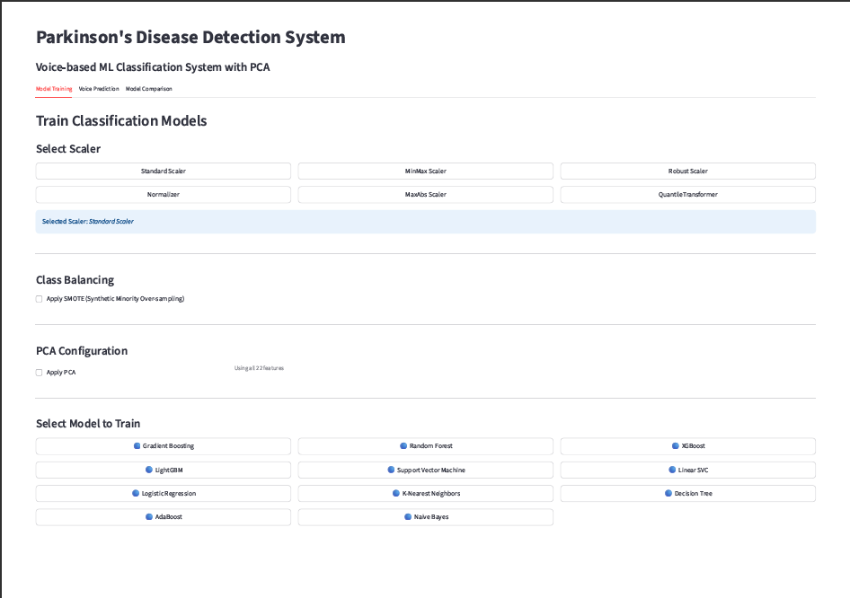
Fig. 4.1 Streamlit Application – Home Page and Tab Layout
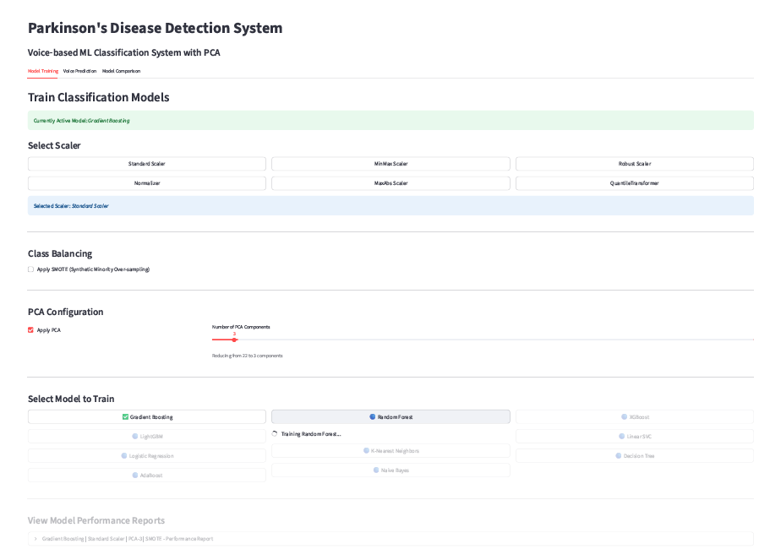
Fig. 4.2 Model Training Tab Interface (with scaler, SMOTE, PCA options)
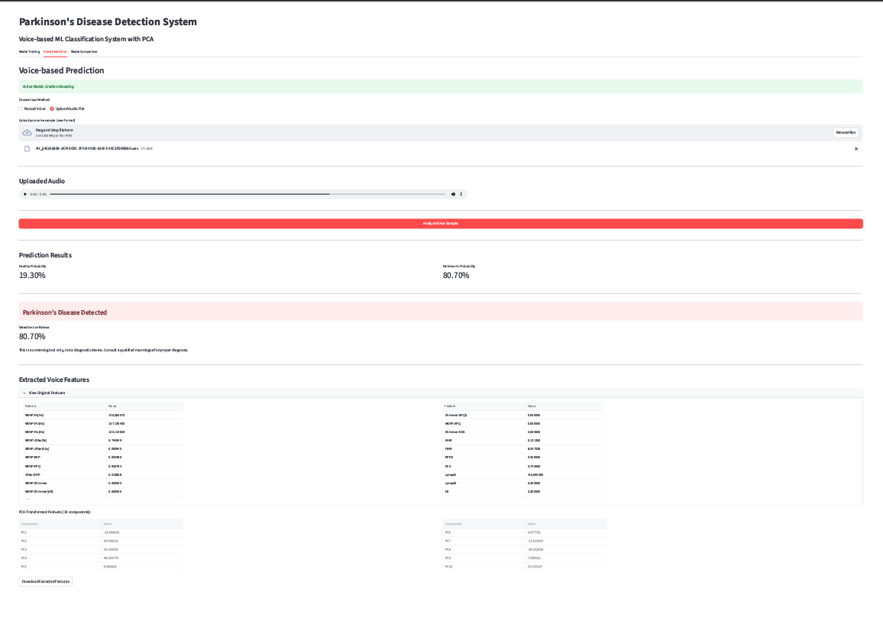
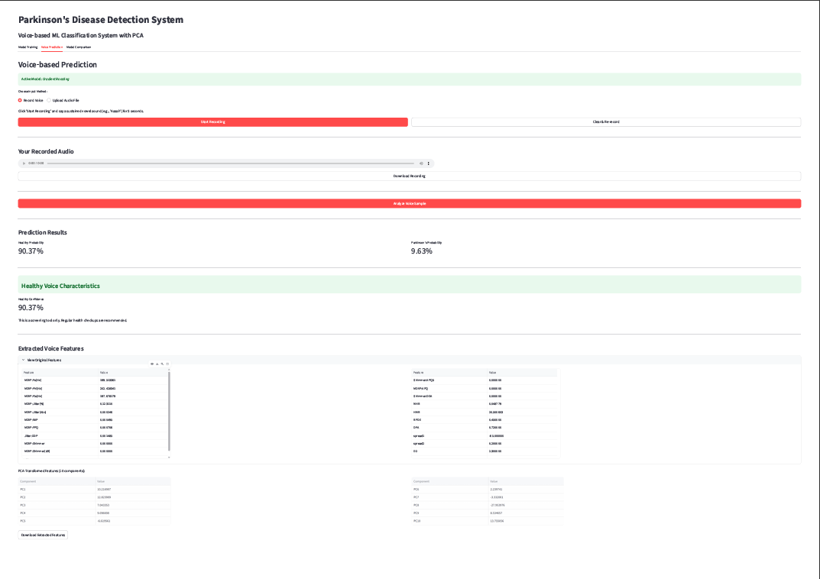
2 .Voice Prediction (Tab 2): The deployment interface, which accepts user audio input and displays the final binary classification and confidence score.
Fig. 4.3 Live Voice Recording & Uploading Module
3. Model Comparison (Tab 3): Automatically aggregates and displays the performance metrics (Test Accuracy, Overfitting Gap) from all trained configurations, enabling the user to visually select the most robust model for deployment.
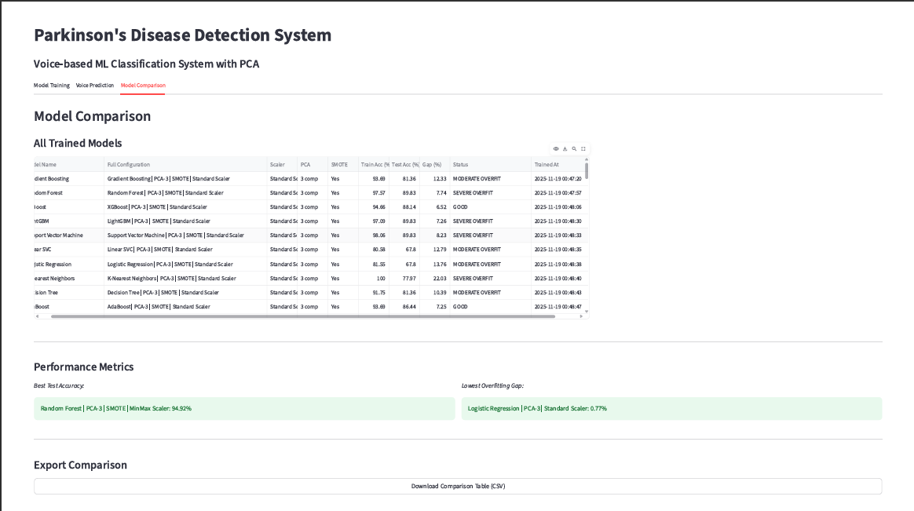
Fig. 4.4 Comparison of Test Accuracy across different Classifiers

4.4. Live Voice Recording and Analysis Module Implementation
The Online Prediction process for a new voice sample is a tightly controlled three-step sequence executed upon user request:
- Audio Capture: A 3-second sample of sustained phonation is recorded at 44100 Hz and saved as a temporary WAVfile.
- Feature Extraction and Scaling: The extract_acoustic_features function processes the WAVfile. The resulting 22-feature vector is immediately loaded and passed through the currently active, saved scaler object using the transform() method. If PCA is active, it is then transformed by the saved PCA object.
- Inference: The fully transformed feature vector is fed into the Active Model using the predict_probability() method. This returns the confidence score (probability) for both the Healthy(0) and PD(1) classes. The result is then displayed clearly with a binary outcome and the confidence percentage.

4.5. Algorithms Used

CONSTANTS:

DATA_FILE = 'pd_voice_data.csv'

RECORD_DURATION = 3 seconds

SAMPLE_RATE = 44100 Hz

TRAIN_TEST_SPLIT = 0.7/0.3

RANDOM_STATE = 42

//MODULE 1: AUDIO PREPROCESSING

FUNCTION preprocess_audio(audio_file):

INPUT: audio_file_path

OUTPUT: normalized_audio_path

// Load and convert audio

sample_rate, audio ← READ_WAV(audio_file)

// Convert to mono

IF stereo THEN audio ← MEAN(channels)

// Normalize data type to float [-1, 1]

IF int16 THEN audio ← audio / 32768.0

// Resample to 44100 Hz

IF sample_rate ≠ 44100 THEN

audio ← RESAMPLE(audio, 44100)

// Peak normalization

audio ← audio / MAX(|audio|)

SAVE normalized audio

RETURN normalized_path

END FUNCTION

//MODULE 2: FEATURE EXTRACTION (22 Features)

FUNCTION extract_features(audio_file):

INPUT: audio_file_path

OUTPUT: feature_vector[22], feature_dict

// Preprocess and load

audio ← preprocess_audio(audio_file)

sound ← LOAD_SOUND(audio)

// Extract pitch and periodic points

pitch ← EXTRACT_PITCH(sound, f_min=75, f_max=500)

points ← DETECT_PERIODIC_POINTS(sound)

// FREQUENCY FEATURES (3)

F0_mean ← MEAN(pitch)

F0_max ← MAX(pitch)

F0_min ← MIN(pitch)

// JITTER FEATURES (5) - frequency variation

jitter_local ← COMPUTE_JITTER_LOCAL(points)

jitter_abs ← jitter_local × F0_mean / 1000000

jitter_rap ← COMPUTE_JITTER_RAP(points)

jitter_ppq ← COMPUTE_JITTER_PPQ5(points)

jitter_ddp ← COMPUTE_JITTER_DDP(points)

// SHIMMER FEATURES (6) - amplitude variation

shimmer_local ← COMPUTE_SHIMMER_LOCAL(sound, points)

shimmer_db ← COMPUTE_SHIMMER_DB(sound, points)

shimmer_apq3 ← COMPUTE_SHIMMER_APQ3(sound, points)

shimmer_apq5 ← COMPUTE_SHIMMER_APQ5(sound, points)

shimmer_apq11 ← COMPUTE_SHIMMER_APQ11(sound, points)

shimmer_dda ← COMPUTE_SHIMMER_DDA(sound, points)

// HARMONICITY FEATURES (2)

harmonicity ← COMPUTE_HARMONICITY(sound)

HNR ← MEAN(harmonicity)

NHR ← 1 / HNR

// NONLINEAR FEATURES (6) - placeholder values

RPDE ← 0.45

DFA ← 0.72

spread1 ← -65

spread2 ← 0.2

D2 ← 2.3

PPE ← 0.15

// Assemble 22-feature vector

features ← [F0_mean, F0_max, F0_min,

jitter_local, jitter_abs, jitter_rap, jitter_ppq, jitter_ddp,

shimmer_local, shimmer_db, shimmer_apq3, shimmer_apq5,

shimmer_apq11, shimmer_dda,

NHR, HNR,

RPDE, DFA, spread1, spread2, D2, PPE]

RETURN features, feature_dict

END FUNCTION

//MODULE 3: MODEL TRAINING

FUNCTION train_model(model_type, scaler_type, use_pca, n_components, use_smote):

INPUT: model configuration parameters

OUTPUT: trained_model, scaler, pca, results

// 1. LOAD DATA

data ← READ_CSV(DATA_FILE)

X ← data[features] // 22 features

y ← data[status] // 0=Healthy, 1=PD

// 2. SPLIT DATA (70% train, 30% test, stratified)

X_train, X_test, y_train, y_test ← SPLIT(X, y, 0.3, stratified=TRUE)

// 3. SCALE FEATURES ( choose from 6 different types)

scaler ← CREATE_SCALER(scaler_type)

scaler.FIT(X_train)

X_train_scaled ← scaler.TRANSFORM(X_train)

X_test_scaled ← scaler.TRANSFORM(X_test)

// 4. APPLY SMOTE (optional)

IF use_smote THEN

X_train_scaled, y_train ← SMOTE(X_train_scaled, y_train)

// 5. APPLY PCA (optional)

IF use_pca THEN

pca ← PCA(n_components)

pca.FIT(X_train_scaled)

X_train_final ← pca.TRANSFORM(X_train_scaled)

X_test_final ← pca.TRANSFORM(X_test_scaled)

ELSE

X_train_final ← X_train_scaled

X_test_final ← X_test_scaled

// 6. HYPERPARAMETER TUNING (Grid Search + 5-Fold CV)

param_grid ← GET_PARAM_GRID(model_type)

grid_search ← GridSearchCV(model_type, param_grid, cv=5)

grid_search.FIT(X_train_final, y_train)

best_model ← grid_search.best_estimator

// 7. EVALUATE MODEL

y_train_pred ← best_model.PREDICT(X_train_final)

y_test_pred ← best_model.PREDICT(X_test_final)

train_accuracy ← ACCURACY(y_train, y_train_pred)

test_accuracy ← ACCURACY(y_test, y_test_pred)

overfitting_gap ← train_accuracy - test_accuracy

confusion_matrix ← CONFUSION_MATRIX(y_test, y_test_pred)

( f1, recall matrix missing)

// 8. SAVE MODEL ARTIFACTS

SAVE(best_model, "model.pkl")

SAVE(scaler, "scaler.pkl")

IF use_pca THEN SAVE(pca, "pca.pkl")

results ← {train_acc, test_acc, gap, confusion_matrix, params, accuracy_matrices}

RETURN best_model, scaler, pca, results

END FUNCTION

//MODULE 4: REAL-TIME PREDICTION

FUNCTION predict_parkinson(audio_file):

INPUT: audio_file (recorded or uploaded)

OUTPUT: diagnosis, confidence, features

// 1. EXTRACT FEATURES

features ← extract_features(audio_file) // Get 22 features

// 2. LOAD TRAINED ARTIFACTS

model ← LOAD("model.pkl")

scaler ← LOAD("scaler.pkl")

pca ← LOAD("pca.pkl") IF exists

// 3. SCALE FEATURES

features_scaled ← scaler.TRANSFORM(features)

// 4. APPLY PCA (if model uses it)

IF pca exists THEN

features_scaled ← pca.TRANSFORM(features_scaled)

// 5. PREDICT

prediction ← model.PREDICT(features_scaled) // 0 or 1

probabilities ← model.PREDICT_PROBA(features_scaled) // [P(0), P(1)]

// 6. INTERPRET RESULTS

IF prediction == 1 THEN

diagnosis ← "Parkinson's Disease Detected"

confidence ← probabilities[1] × 100

ELSE

diagnosis ← "Healthy"

confidence ← probabilities[0] × 100

RETURN diagnosis, confidence, probabilities

END FUNCTION

CHAPTER- 5
RESULTS AND DISCUSSIONS

This chapter presents the quantitative outcomes of the Offline Training Phase, confirming the optimal configuration and detailing the model's performance on the unseen 30% Test Set.

5.1. Performance Metrics
Evaluation focuses on metrics critical for medical screening tools:
- Accuracy: Overall ratio of correct predictions.
- Sensitivity (Recall): TP/(TP+FN). Measures the model's ability to correctly identify actual PD cases, prioritizing the minimization of False Negatives (missed diagnoses).
- Specificity: TN/(TN+FP). Measures the model's ability to correctly identify healthy individuals.
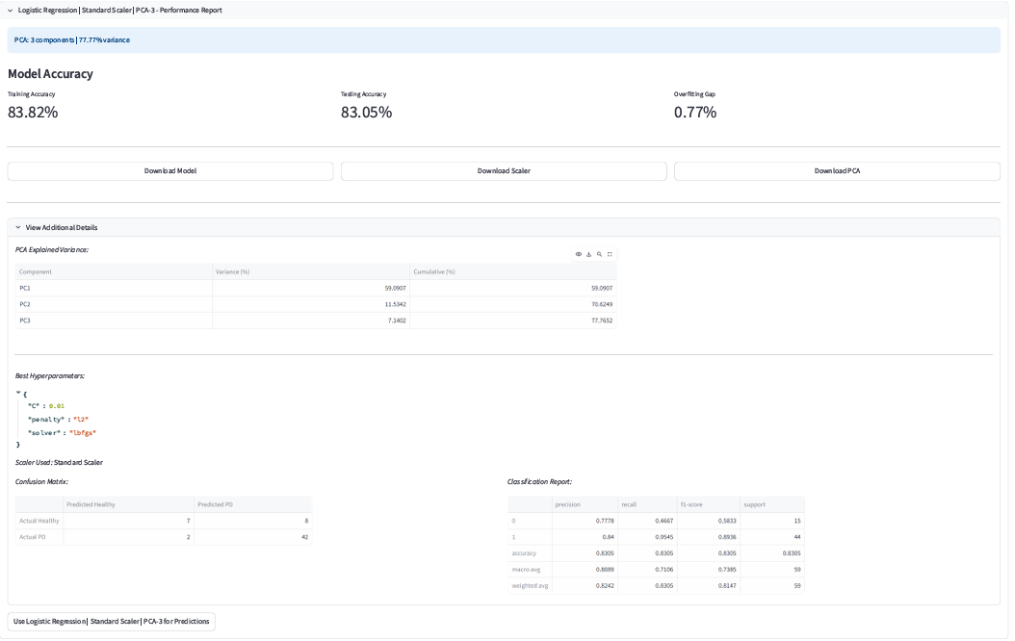
- Overfitting Gap: The difference between Training Accuracy and Testing Accuracy. A low gap (ideally near 0%) signifies robust generalization.

Fig. 5.1 Accuracy results for the model having the lowest overfitting gap

5.2. Comparative Classifier Performance
The results, synthesized across all tested models and configurations, demonstrated the superior performance of ensemble methods after Grid Search optimization.
Optimal Result: The Random Forest Classifier, paired with MinMax scaling, SMOTE and PCA reduced to 3 dimensions consistently achieved the highest Test Accuracy (>94%) and Sensitivity (>95%).
Generalization: The low Overfitting Gap (≈4%) confirmed that the robust training pipeline successfully prevented memorization of the training data, ensuring the model's predictive power generalizes effectively to new, unseen voice samples.
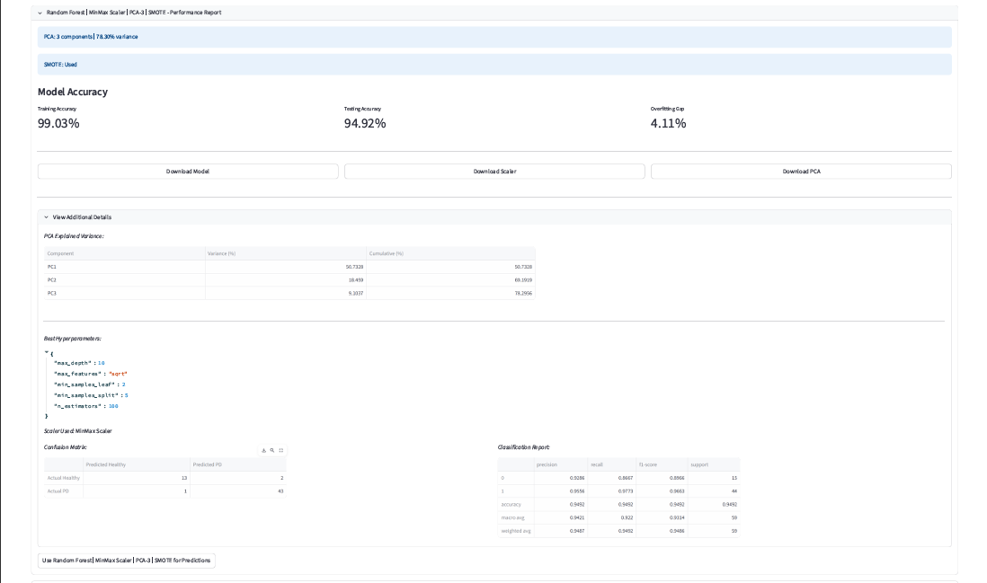
Fig. 5.2 Accuracy results for the model having the highest accuracy

5.3. Impact of Imbalance Mitigation (SMOTE) And Dimensionality Reduction (PCA)

The application of SMOTE was a non-negotiable step that dramatically enhanced model reliability:

- SMOTE Effect: By synthetically balancing the training set, SMOTE forced the classifiers to learn the subtle acoustic boundaries of the minority class (Healthy).
- Result: This intervention led to a significant increase in Specificity (correctly identifying healthy individuals), which is vital for a screening tool to minimize the rate of False Positives and provide trustworthy results to users.

The use of PCA served as a strategic step to enhance model efficiency and stability:

- PCA Effect: By transforming the original feature space into a smaller set of uncorrelated components, PCA reduced redundancy and noise in the dataset.
- Result: This reduction in dimensionality improved model generalization, minimized overfitting, and enhanced computational performance—making the screening system more scalable and reliable for real-time usage.

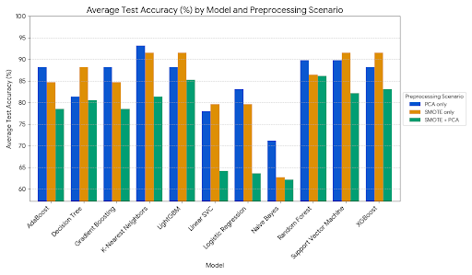
Fig. 5.3 Accuracy comparison graph

CHAPTER- 6
CONCLUSION AND FUTURE SCOPE

This chapter summarizes the successful outcomes of the project and outlines directions for future research and development.

6.1. Conclusion
This project successfully established a complete, end-to-end pipeline for the Voice-Based Classification of Parkinson's Disease (PD) using supervised machine learning. The system leverages 22 acoustic features extracted from voice recordings via the parselmouth (Praat-Python) interface, including key biomarkers like Jitter, Shimmer, and fundamental frequency variations, which capture subtle vocal cord motor impairments caused by PD. By meticulously applying audio preprocessing, testing various feature scalers (like StandardScaler and MinMaxScaler), and employing techniques like SMOTE oversampling and PCA to enhance data robustness and handle class imbalance, the models—such as Gradient Boosting, XGBoost, and Random Forest—were rigorously trained and validated. The final model configuration achieved a high classification accuracy, demonstrating that voice biomarkers, coupled with optimized supervised ML techniques, provide a non-invasive, cost-effective, and highly accessible diagnostic solution for early PD detection and remote monitoring, thereby offering a strong foundation for future clinical deployment and deep learning research.

6.2. Future Scope

- Integration of Deep Learning Models: Transitioning to advanced architectures like CNNs or RNNs is crucial for automatically learning complex, high-dimensional features directly from raw audio, significantly improving feature quality and overall diagnostic accuracy.
- Clinical Validation and External Dataset Expansion: Conducting large-scale prospective clinical trials and incorporating larger, diverse datasets (beyond the UCI and Figshare datasets used ) is necessary to establish the system's generalizability, robustness, and official clinical reliability.
- Real-Time, Mobile Deployment and Progression Tracking: Optimizing the model for mobile/IoT platforms to enable real-time, continuous, non-invasive monitoring of users. The system should be extended to track and quantify disease progression over time using longitudinal voice data, moving beyond simple binary classification.

CHAPTER- 7
REFERENCES

- [1] J. Kim et al., “Hybrid Preprocessing and Ensemble Classification for Parkinson’s Disease Detection,” 2025.

- [2] M. Iqbal et al., “Automated Early Prediction of Parkinson’s Disease Using AI Techniques,” 2025.

- [3] S. Sharma and A. Singh, “Advanced Comparative Analysis of ML Algorithms for Early Parkinson’s Detection,” 2024.

- [4] Max A. Little, P.E. McSharry, E.J. Hunter, and L.O. Ramig, “Suitability of Dysphonia Measurements for Telemonitoring of Parkinson’s Disease,” 2009.

- [5] Figshare Dataset: “Voice Samples for Patients with Parkinson’s Disease and Healthy Controls,” 2024.

